(Approx. 1051 words)

A Tour of the Yahoo Finance Website
Part 2 of 2
By Tom Burt, Vice President
Sun City Summerlin Computer Club
https://www.scscc.club
tomburt89134 (at) cox.net

Introduction

This month we’ll continue our tour of the Yahoo Finance website: https://finance.yahoo.com. Part 1 can be found in the February 2022 Gigabyte Gazette (https://www.scscc.club/Gigabyte/gg_2022-02Feb.pdf). In this article, we’ll cover how to set up watch lists and portfolios and how to create custom views for these.

Yahoo Finance Portfolios

A Yahoo Finance portfolio is a named list of stocks, bonds, funds, or options. You can create lists of securities you own or watch, usually with some interest in buying or possibly short selling. A portfolio is displayed as a table with either a Yahoo pre-defined view or a custom view you created. A View specifies a set of data columns whose values will be displayed for each security row of the table.

You can enter multiple lots bought at different times and prices for a portfolio of securities you own. For each lot, there’s a comments field; I use that to indicate which brokerage account that lot is owned in. Then, Yahoo automatically merges the lots and computes the average purchase price for each ticker symbol when viewing your portfolio.

A “watch list” portfolio is a list of stocks, bonds, funds, or options you do not own but monitor. Again, there are no lots recorded – only the ticker symbols.

Creating a Portfolio

At the top of the home page is a gray band with links for Finance Home, Watchlists, My Portfolios, Cryptocurrencies, Screeners, Yahoo Finance Plus, Markets, News, and others under the “…”. Click the “My Portfolios” link. Yahoo Finance will display a summary list of all your portfolios. The names of the various portfolios in this list are hyperlinks. Click the name to display that portfolio’s list of equities as a table. Alternatively, you can hover your mouse over the “My Portfolios” link, and a dropdown list of all your portfolio names will appear. Click on one of the names to display that portfolio.

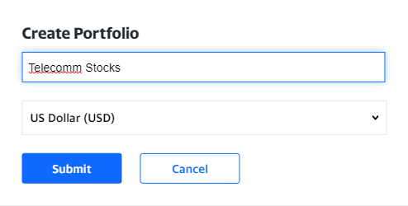
In either the summary list or a listing of a specific portfolio, at the upper right is a “Create Portfolio” link. Click this to launch a small Create Portfolio dialog.

Enter the portfolio’s name and click Submit.

The screen will then display a new, empty portfolio. Click the “Add Symbol” link above the Symbol column to add items to the portfolio. A search box will appear. You can type in a security symbol or the security/company name. A list of matches will appear from which you can choose the desired symbol. In the screenshot following, I’ve added five symbols: BCE, LUMN, TMUS, VZ, and T. The tabular view is a custom I built named TomWatch (more on later).

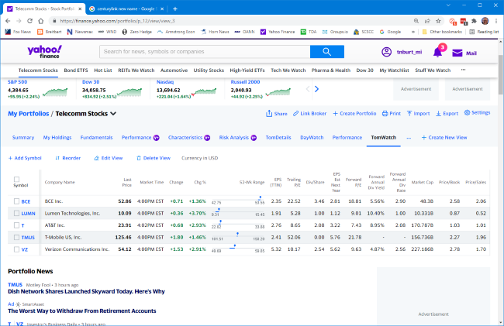

Because I’ve entered no holdings, Telecomm Stocks is initially a watch list specifically focused on stocks in the telecommunications industry. Some of my other watch lists include Automotive, Pharma & Health, Utilities, Energy, and REITs. I also have a short list of stocks I’m actively watching called “Hot List.”

You can click on the column headings to sort the table in ascending or descending order on that column. For example, when the portfolio has many entries, it can be handy to sort in descending order by Forward dividend yield, Market cap, PE Ratio, or percent gain. To make the new sort permanent, click the Reorder link and Save.

To remove an item from the list, hover over it. The item will highlight in pale blue, and a small x will appear at the right edge. Click the x and then confirm the delete.

Adding Lots

In a portfolio that tracks securities you own, you will want to record how many shares you own, when you bought the shares, and how much you paid. This is because you may have purchased more than one lot of a security at different times and prices, perhaps in different accounts.

To add lots to security in a list, select the list and click on the “My Holdings” View (see the screenshot below). Next, click the “+ Add Lot” link to display a row of entry fields.

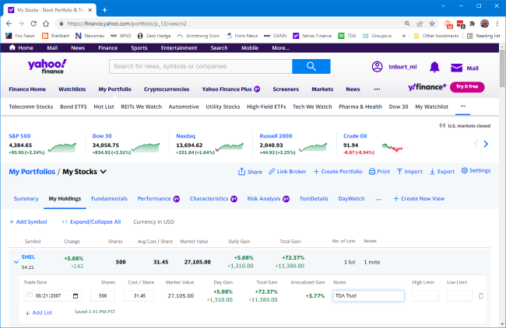

Fill in the trade date, number of shares, cost/share, and add a note indicating which account will hold the shares. Continue to do this for each lot. Next, click the small down v to close up the lot list for that security. Then move on to the next security in the list until all lots have been added for all securities in the list. The end result should look something like this.

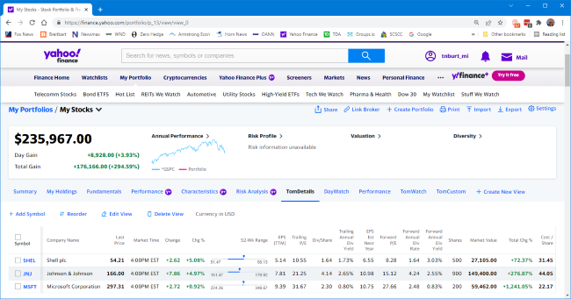

If you have entered multiple lots for a security, Yahoo Finance will total the share counts and average the cost per share in the single line in the table display. For example, in the above screenshot, we see a custom view named Tom Details. It has quite a few columns, including Market Value and Percent Gain, at the far right.

Creating Custom Views

Yahoo offers a few built-in views of portfolios – Summary, “My Holdings,” Fundamentals, “Day Watch,” and Performance. You can also create personal custom views. While viewing a portfolio, click the “+ Create New View” link. A View editing dialog will appear.

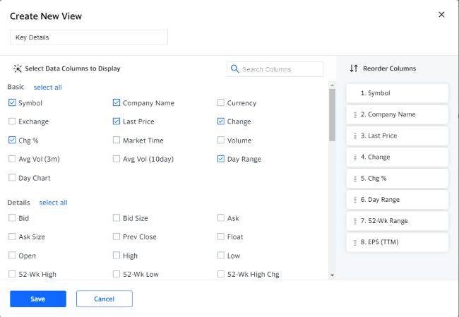

Enter a name for the new View and then click on checkboxes for the columns you wish to see in that View. The selected columns appear in a list to the right. The list of selectable columns is scrollable. As a practical matter, you can only choose about a dozen columns; after that, the table gets too wide for the screen. You can click and drag on a column in the right-hand pane to move it to a different position. When you got everything set up to suit, click the Save button. Your new View will now appear in the list of views above the display of your portfolios. When you have a View selected, you can click the “Edit View” link to modify that view. The same editor will appear. Finally, you can click the “Delete View” link to remove a View. A confirmation popup will appear for the Delete.

Summary

Yahoo Finance is a great tool for tracking securities you own and securities you want to follow. We’ve covered many key features, but there are a lot more. Check it out yourself.

